Topic 5 :

# Lesson 1 : Decision Making.

# Decision making means the action of taking decisions and choosing the action plan accordingly.

# *In programming we face some situations where we want a certain block of code to be executed when some condition satisfy.*

# *A programming language uses control statements to control the flow of execution of a program based on certain conditions.*

# *There are many ways of exercising decision making in java.*

# If

# If else

# nested if

# switch

# We will learn only the first two ways of decision making .

1. If Statement in Java

Java if statement is the simplest decision making statement. Code will executed only when the condition evaluates to true.

if (condition )

{

// code to be executed

}

For Flow diagram for if statement [click here.](https://data-flair.training/blogs/wp-content/uploads/sites/2/2018/01/Flow-diagram-for-if-statement.jpg)

1. If-else Statement in java

 The if statement alone tells us that if a condition is true it will execute a block of statements and if the condition is false it won’t. But what if we want to do something else if the condition is false.  Here comes the else statement.

When the condition of if statement is false then the else part of code will execute and else statement does not contain any condition.

***It is like You have two option and if your 1st option is wrong then there is no choice left ,you have to chose the 2nd option .***

**if(condition)  
{**

**//code to be executed if the condition is true  
}**

**else  
{**

**//code to be executed if the condition is false**

**}**

Flow diagram of If-else Statement [click here.](https://data-flair.training/blogs/wp-content/uploads/sites/2/2018/01/Flow-diagram-of-if-else-statement.jpg)

**Lets Code**

1. Take values of length and breadth of a rectangle and check if it is square or not.

Solution :-

First we open our notepad

Create a public class ***ifelse***

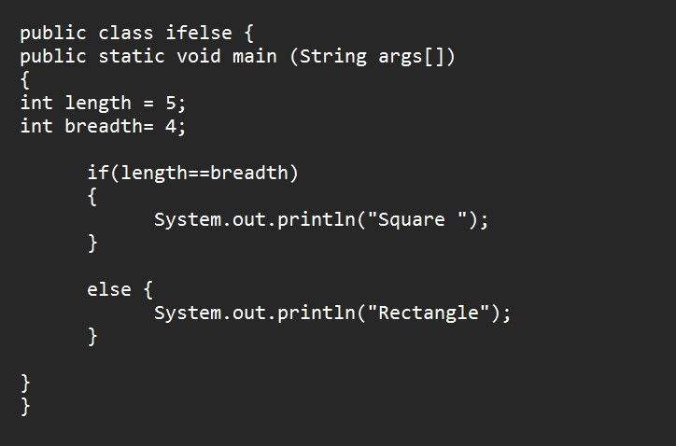

WHAT Exactly happens here,

For a square length and breadth should be same , here length is 5 and breadth is 4 , both are different .

‘if’ conditions is wrong that is (length == breadth ). Else part of code will executes

Output :

